Name : Vishal Jha

Batch : Data Engineering

Date : 23-01-2024

Topic : Data Cleaning & Transformation queries , Ranking Function & Stored Procedure

1. Created a database.

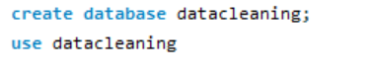

1. Created a table and inserted demo values with Duplicate and NULL values.

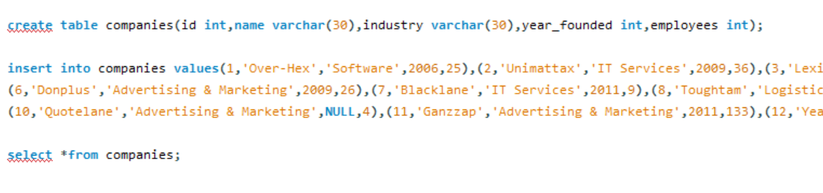

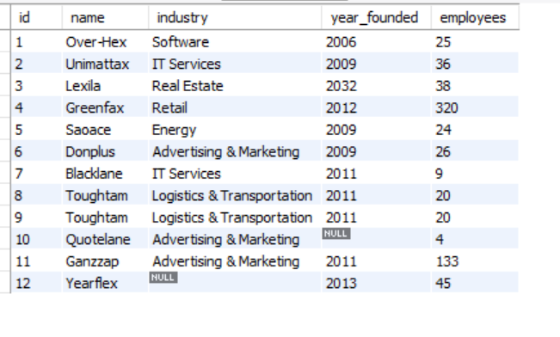

1. Getting Duplicate data.

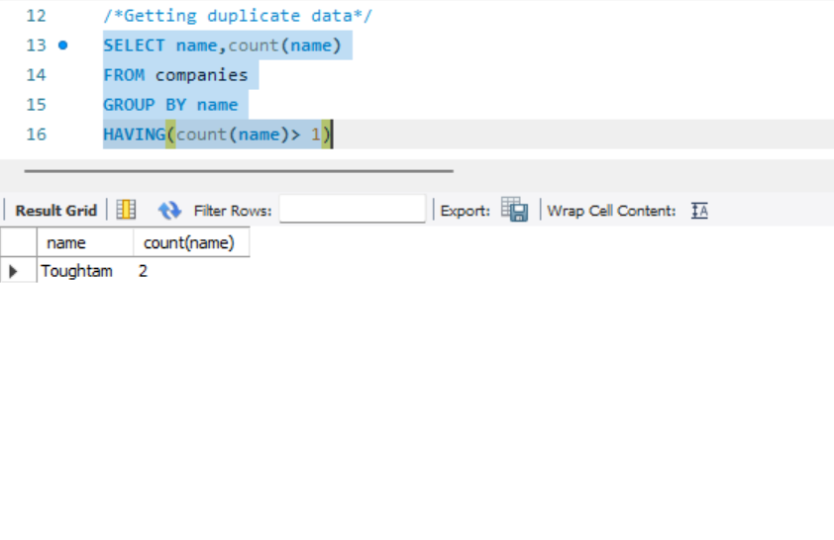

1. Assigning ranks to the row.

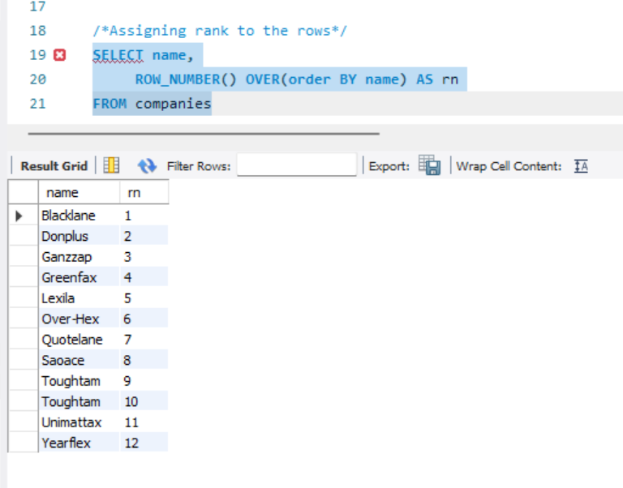

1. Deleting Duplicate values

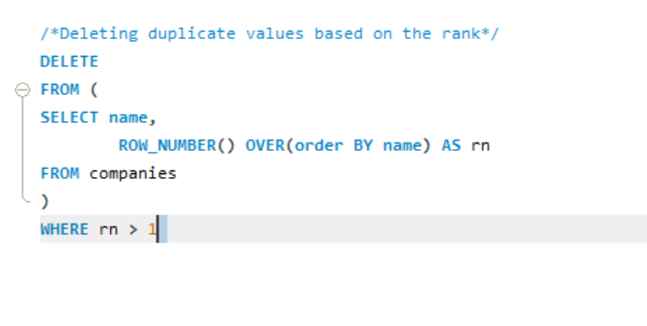

1. Finding NULL values.

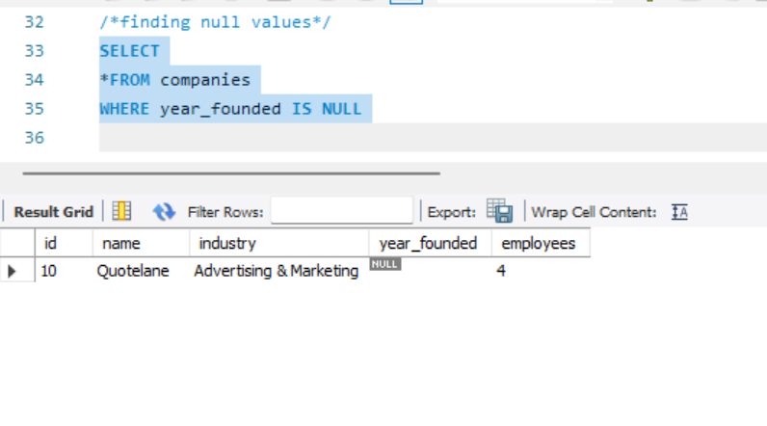

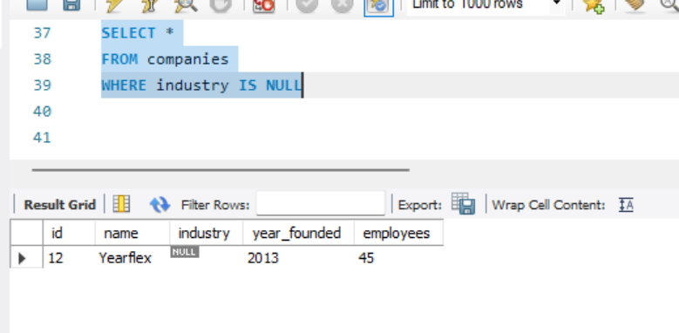

1. Removing NULL values.

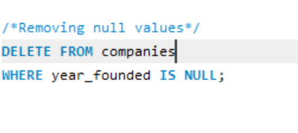

1. Updating Null Values with same meaningful value.

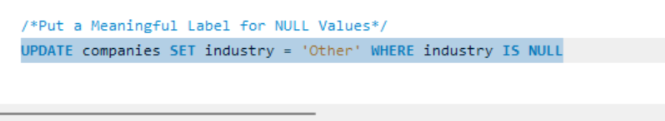

1. Creating a Stored Procedure.

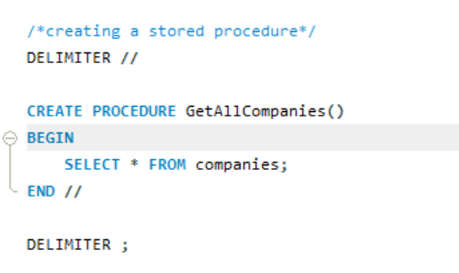

1. Executing Stored Procedure.

